ASR 5975

Request:

Request to search by warehouse code which will map the HU prefix in code setup.

Current:

User input HU prefix to retrieve report:

i.e 102%

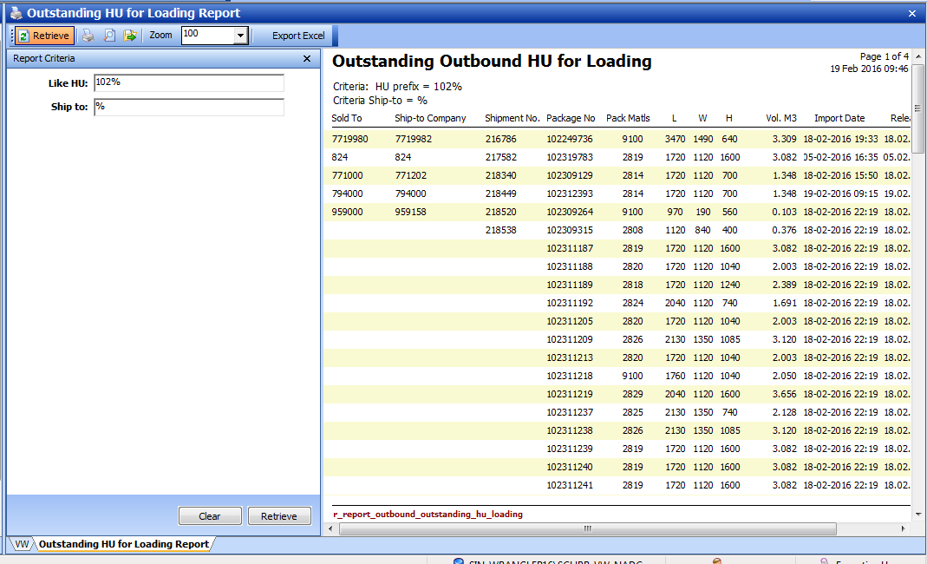

Request:

Retrieve by Warehouse Code:

SLC – Prefix HU 101, 103

TLC – Prefix 102

Allow user to add-on new HU prefix code.